

**PROGRAMME :**

**DIPLOMA IN INFORMATION TECHNOLOGY**

**(DIGITAL TECHNOLOGY)(DDT)**

**COURSE:**

**DFP30243 - OBJECT ORIENTED PROGRAMMING**

|  |  |  |
| --- | --- | --- |
| **ASSESMENT** | **LABORATORY TASK 4** | |
| **NO** | **REGISTRATION NO** | **NAME** |
| 1. |  |  |
| 2. |  |  |
| **PROGRAMME** |  | |

INSTRUCTIONS :

1. Answer **ALL** the questions.
2. Submission Date : ……………………………………………………

|  |  |  |  |  |
| --- | --- | --- | --- | --- |
|  | | | | |
| **CODE / COURSE** | **DFP30243 -**  **OBJECT ORIENTED PROGRAMMING** | **LABORATORY TASK** | **~~1 / 2 / 3~~ / 4** | |
| **PROGRAM / CLASS** |  | **DURATION** | **2 HOURS** | |
| **STUDENT’S NAME** |  | **CLO** | **1P** |  |
| **REG. NO.** |  | **TOTAL MARKS** | **/50** | |
| **LECTURER’S NAME** | **PN. HAZLEENA BINTI OSMAN/**  **PN. RODZIAH BINTI IBRAHIM** |

**CLO1 :** Construct Object Oriented Programming concept and exception handling in Java programming (P4, PLO3)

**Learning outcomes:**

Upon completion of this lab, students should be able to:

* + - 1. Build Java program using Exception Handling

**INSTRUCTION: Answer all questions.**

|  |
| --- |
| **QUESTION 1**  The following program will get an input of radius and height from user and calculate a surface area of Cone. Rewrite the Java code below and use exception handling to handle the possible generated exception and display the output.    **Sample Output:**  ***Output 1: Output when all the input correctly inserted***    ***Output 2: Output when height/radius incorrectly inserted***    **(25 marks)** |
| **A. Source code**  **\*snip and paste your source code here. (Make sure it is snipped from your text editor/ java platform). Refer Appendix 1 for an example.** |
| **B. Output**  **\*snip and paste your output here. (Make sure it is from your command prompt/ java platform). Refer Appendix 1 for an example.** |
| **QUESTION 2**  *Majlis Keselamatan Negara* (MKN) had been instruct all the premises in Malaysia must be able to record the customer information including their body temperature before entering the premise. As a programmer in Laypark Sdn. Bhd., you need to construct a Java program to get an input of customer by incorporating the following:   1. Get the input name, phone number and body temperature from **FIVE (5)** customers using ‘for’ loop. If the customer input the non-numeric format for temperature, use suitable exception handling to catch the exception. Otherwise, print *“Welcome to Laypark”.* 2. Add a message *“Thank you. Have a nice day.”* regardless if the program raises an error or not.   **Sample output:** *(this sample only shows 2 out of 5 customers*)  ***Output 1: If all customers input the correct info.***    ***Output 2: If the customer input the incorrect temperature.***    **(25 marks)** |
| 1. **Source code**   **\*snip and paste your source code here. (Make sure it is snipped from your text editor/ java platform). Refer Appendix 1 for an example.** |
| 1. **Output**   **\*snip and paste your output here. (Make sure it is from your command prompt/ java platform). Refer Appendix 1 for an example.**  ***Notes: Please shows all 5 customers detail.*** |

***Appendix 1***

**Example of source code:**

1. If you use Java platform to write the source code

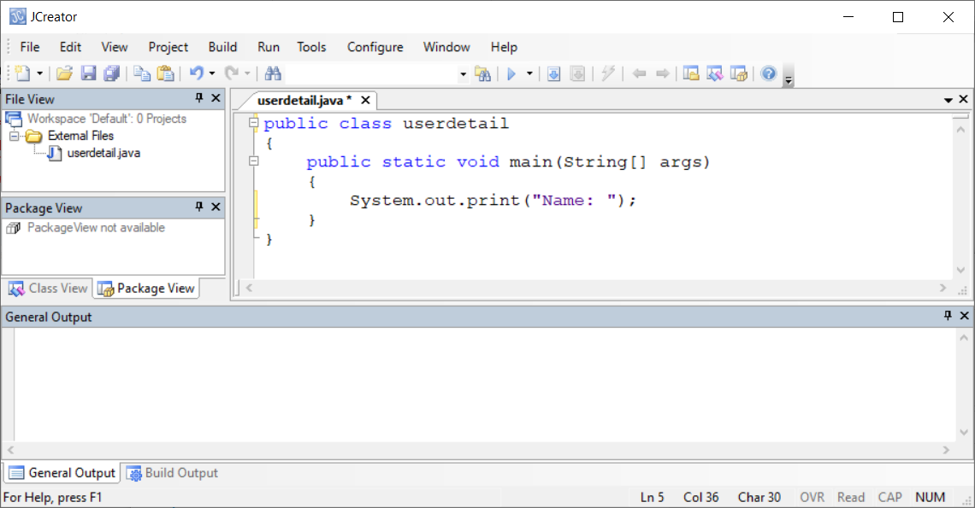

1. If you use text editor to write the source code

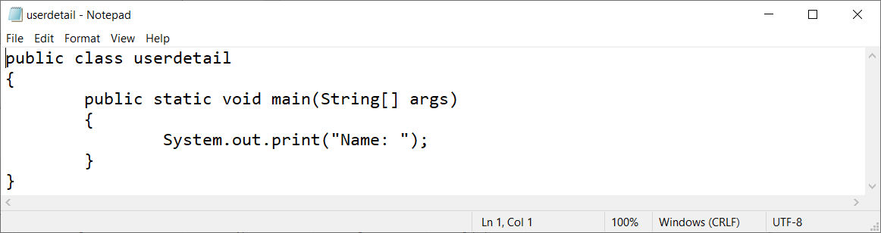

**Example of output:**

1. If you use Java platform to compile and execute

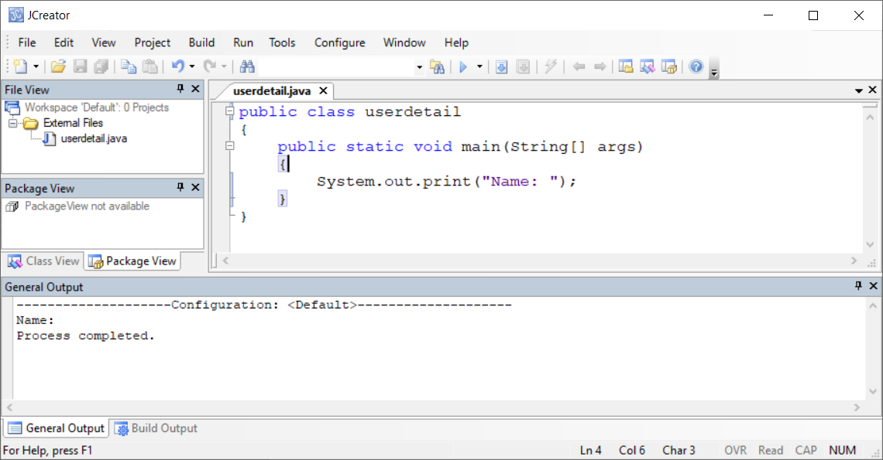

1. If you use Command Prompt to compile and execute

